Online Coffee & Pastry Ordering System
The Online Coffee & Pastry Ordering System is a simple web-based system that allows customers to order coffee and pastries online. Customers can browse the menu, add products to their cart, place orders, and make payments. The system helps reduce waiting time and makes ordering more convenient for customers.
The system also allows an admin to manage the products available in the store. The admin can add new pastries or coffee items, update prices, and view customer orders. This helps the shop manage inventory and monitor sales efficiently.

Actors / Users
- Customer
- Admin

Main System Functions
Customer:
- Register / Login
- View Menu
- Add Items to Cart
- Place Order
- Make Payment
Admin:
- Login
- Add Products
- Update Products
- Delete Products
- View Orders

UML Diagram (Use Case Diagram)
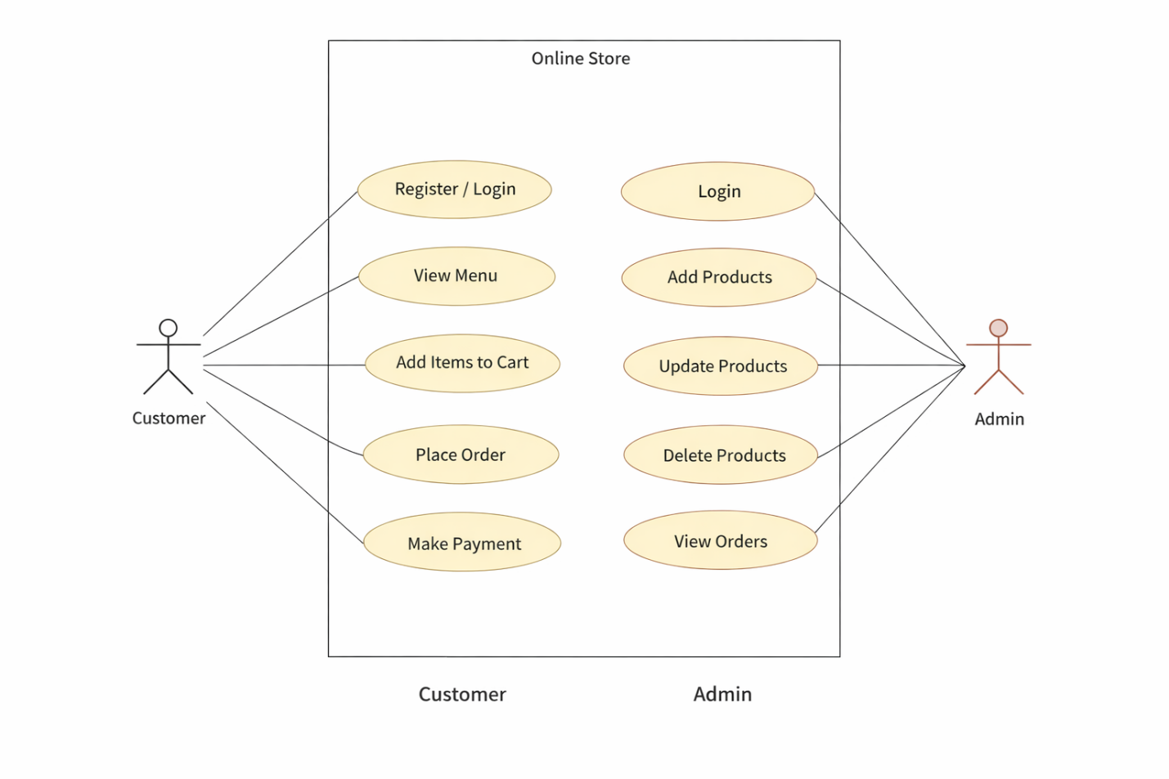

The Use Case Diagram shows the interaction between users and the system. The Customer can register, browse the menu, add items to the cart, and place orders. The Admin manages the products and monitors customer orders. Each function represents a task the user can perform in the system. This diagram helps visualize how users interact with the online ordering system.

